Kalmyk Cultural Heritage Documentation Project Website

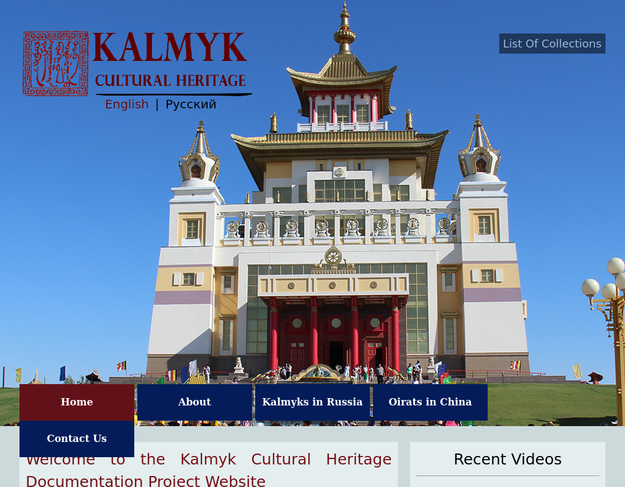

### identifier

643e6c5c-c926-4a4d-b71d-425fc32551f3

### creator

MIASU

### type

Text

### coverage

Russia

Kalmykia

### description

The Kalmyk Cultural Heritage Documentation Project aims to video-audio document Kalmyk culture in the broadest sense and to produce a comprehensive database on the endangered cultural heritage of the Kalmyks in Russia and their kinsmen, the Torghuts, in China. The project hopes that this on-line knowledge will not only provide the communities with a resource that they can draw upon to compare, study and popularise their culture but also contribute to cultural preservation and revitalisation both in Kalmykia and beyond.

The majority of documentation will be carried out in the Republic of Kalmykia - the focus area of the project - and the adjacent Astrakhan region. In China, we will document the cultural heritage preservation activities in three widely dispersed Oirat/Torghut communities: Chengde /Weichang in Hebei, Ejene in Inner Mongolia, and Bortala/Hoboksar in Xinjiang, respectively. The project is a collaborative endeavor involving international academics from the UK, Mongolia, Russia, China and other countries.

### publisher

Kalmyk Cultural Heritage Documentation Project

MIASU

### source

<http://www.kalmykheritage.socanth.cam.ac.uk/en/index.php>

### rights

Creative Commons Atrribution-NonCommercial-NoDerivatives license (unported).

### subject

cultural heritage

Kalmyks

### date

2017-05-25 10:53:55

### language

English

Russian

### original filename

kalmyk-cultural-heritage-website.url

### extent

57.0 B

### format

text/plain

### modified

2017-05-25 08:42:28