Caroline Humphrey - Buryatia photos - No. 4-19

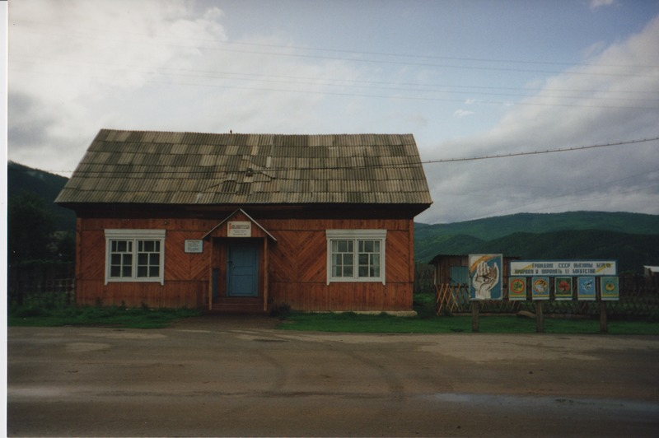

### identifier

65b3f722-08a3-4bb9-bad0-b832efd127be

### creator

Humphrey, Caroline

### type

Image

### coverage

Uro

Bayangol

Buryatia

USSR

### description

Library.

### publisher

### source

Scanned from a print held in the archives of the Mongolia and Inner Asia Studies Unit, University of Cambridge.

### rights

### subject

### date

1993

### language

### contributor

### original filename

Humphrey-Buryatia-photos-4-19.png

### relation

### extent

3.1MiB

1799x1196 px

### format

image/png