Disappearing World: a guide for anthropologists

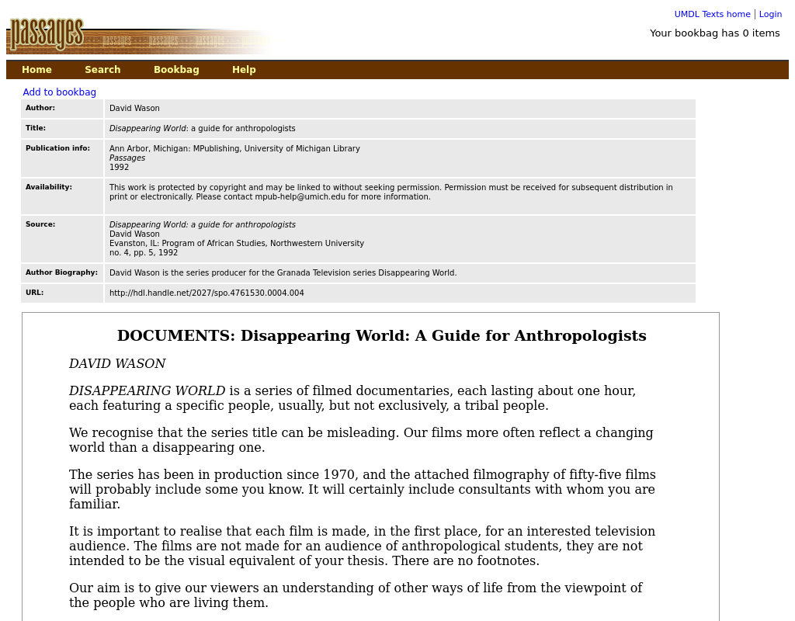

### identifier

65f6a669-3f15-423f-8f48-5b450d4c1c24

### creator

Wason, David

### type

Text

### coverage

### description

Guidelines for anthropologists participating in the Granada Television series “Disappearing Worlds”

### publisher

MPublishing, University of Michigan Library

### source

<http://hdl.handle.net/2027/spo.4761530.0004.004>

### rights

This work is protected by copyright and may be linked to without seeking permission. Permission must be received for subsequent distribution in print or electronically. Please contact mpub-help@umich.edu for more information.

### subject

ethnographic film

### date

1992

### language

English

### format

text/plain

### original filename

disappearing-world-guide.url

### extent

139.0B

### public

FALSE