Photographs from Barguzin, No. 13

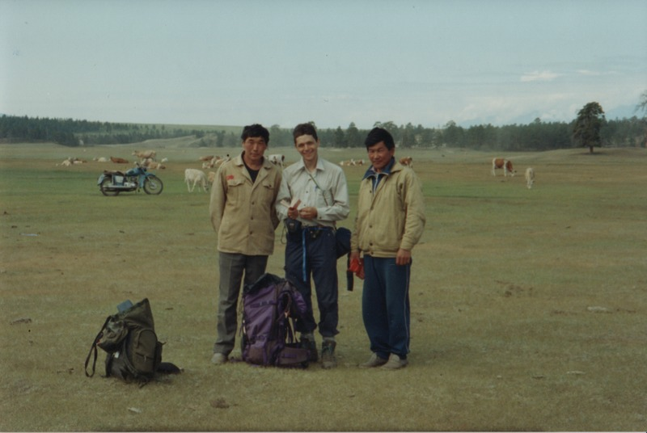

### identifier

662ed182-95bc-4862-afb2-8f77c099a62a

### creator

Gomboev, Bair

### type

Image

### coverage

Barguzin

Burtyatia

Russian Federation

### description

Summer pastures, close to Bayangol village, in poor condition.

### date

1993-06

### language

### format

image/png

### modified

2017-05-25 02:07:48

### original filename

bair-batbuyan-photos-13.png

### source

Scanned from a photographic print held in the archives of the Mongolia and Inner Asia Studies Unit, University of Cambridge

### extent

2.8 MiB

1777x1191 px

### subject

rangeland