Photograph from Inner Mongolia, No. 04

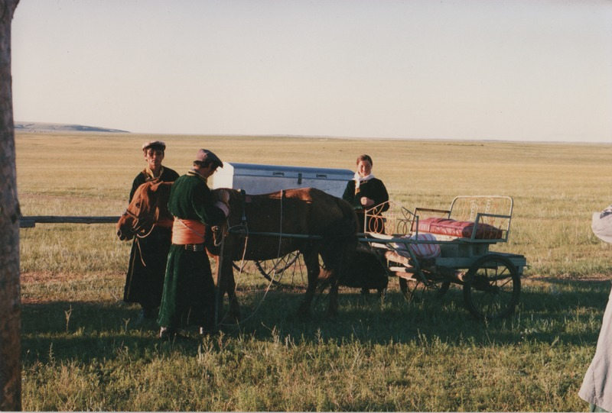

### identifier

66faf25a-7d9b-4102-87e8-9f086ae4f076

### creator

Sneath, David

### type

Image

### coverage

Inner Mongolia

PRC

### description

Horse-drawn buggy in the steppe.

### publisher

### source

Scanned from a photographic print held in the archives of the Mongolia and Inner Asia Studies Unit, University of Cambridge.

### rights

### subject

horse-carts

### date

ca. 1988

### language

### original filename

sneath-inner-mongolia-1980s.png_04.png

### relation

### extent

3.1 MiB

1747x1182 px

### contributor

### format

image/png

### modified

2017-05-25 10:58:40