Photograph from Govisumber, No. 12

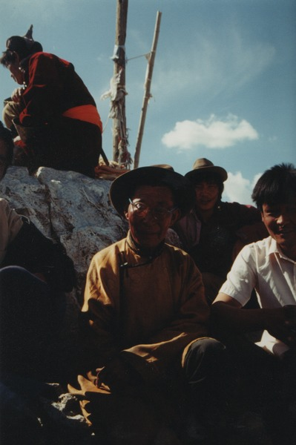

### identifier

6710ce30-6624-403b-9bb2-c9542c9d2e77

### creator

Sneath, David

### type

Image

### coverage

Govisumber aimag

Mongolia

### description

### publisher

### source

scanned from a photographic print held in the archives of the Mongolia and Inner Asia Studies Unit, University of Cambridge

### rights

### subject

ovoo

### date

1995

### language

### format

image/png

### contributor

### original filename

sneath-govisumber_12.png

### relation

### extent

1182x1776 px

3.2MiB