Vitafit factory tour image - 1npaciu34hg9ubajig364nnk8i l

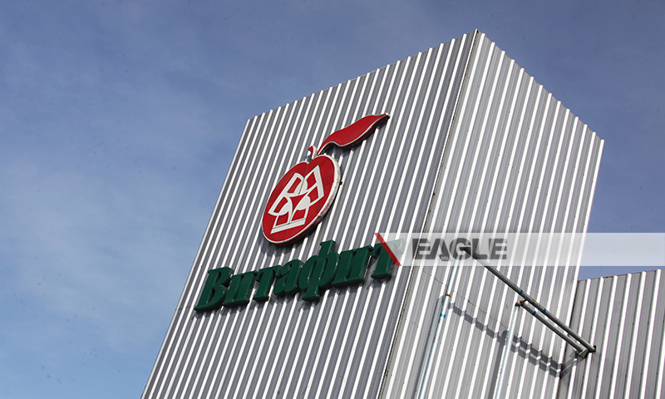

### identifier

671fdd76-8ab0-4b0e-8b94-f3a5b7a7c7ca

### creator

### type

Image

### coverage

Mongolia

### description

Goyo yogurt factory tour image published by Eagle.mn.

### publisher

### source

### rights

### subject

Mongolia

dairy

nationalism

social media

### date

2014

### language

Vitafit factory tour image - Vitafit factory tour image - 1npaciu34hg9ubajig364nnk8i l

### format

image/jpeg

### original filename

1npaciu34hg9ubajig364nnk8i_l.jpg

### extent

331.9 KiB

800x480 px

### modified

2014-03-24 18:28:48