Visit with Mendee and his brothers - Yeröö

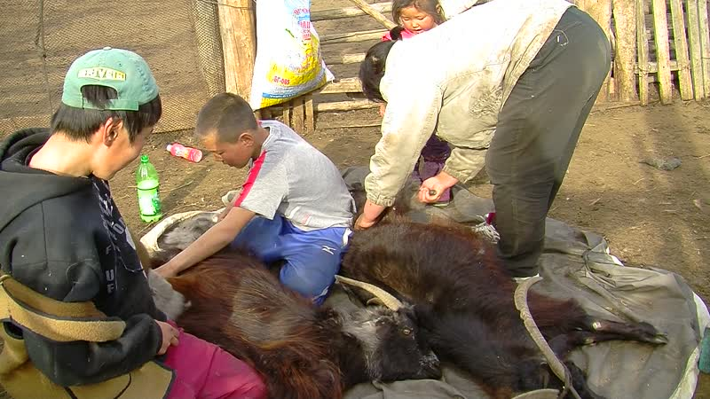

### identifier

68f2a88c-3c9b-4899-9ff1-421b6c7245cf

### creator

Thrift, Eric

### type

Moving Image

### coverage

Mongolia

Selenge aimag

Yeröö sum

### description

This series of audiovisual recordings documents activities at Tasag in Yeröö sum, Selenge aimag. We first visit Mendee, who feeds his pigs and chickens, then takes us to see the stump of a tree that was knocked down by lightning in the nearby pasture. Mendee, his son and nephews load plastic barrels onto the back of their truck and drive over to the creek, about 300 metres from their home, to get water for the vegetable garden. Next we drive down the road to Mendee's brother Bat-Erdene's home, where his wife is busy combing goats. Afterwards we visit another brother, Batsaikhan, who brings the sheep and goats into the livestock pen as it begins to get dark. Batsaikhan talks about his experiences growing up in a family of Buryat herders working for the former State Farm, and his efforts to keep Yeröö sheep, which he is cross-breeding with local sheep breeds.

### publisher

### source

### rights

### subject

Pastoralism Videos

Feeding Pigs

Feeding Chickens

Fetching Water

Combing Goats

Evening Activities

Mendee-Bat-Erdene-Batsaikhan

### date

2012-04-21

### language

### format

inode/directory

### modified

2018-01-18 10:46:11

### original filename

PastoralismVideos--2012-04-21--FeedingPigs--FeedingChickens--FetchingWater--CombingGoats--EveningActivities--Mendee-Bat-Erdene-Batsaikhan--Selenge-Yeroo.vclips

### table of contents

|  |  |  |
| --- | --- | --- |
| time | clip | description |
| 0:00:00 | 244 0289 01 | Visit with Mendee |
| 0:13:54 | 244 0289 02 |  |
| 0:16:48 | 244 0290 01 |  |
| 0:18:27 | 244 0291 01 |  |
| 0:19:09 | 244 0292 01 |  |
| 0:33:03 | 244 0292 02 |  |
| 0:46:22 | 244 0293 01 |  |
| 1:00:17 | 244 0293 02 |  |
| 1:13:19 | 244 0294 01 |  |
| 1:27:13 | 244 0294 02 |  |
| 1:40:25 | 244 0295 01 |  |
| 1:52:49 | 244 0295 02 |  |
| 2:00:51 | 244 0296 01 |  |
| 2:14:45 | 244 0296 02 |  |