Caroline Humphrey - Buryatia photos - No. 2-23

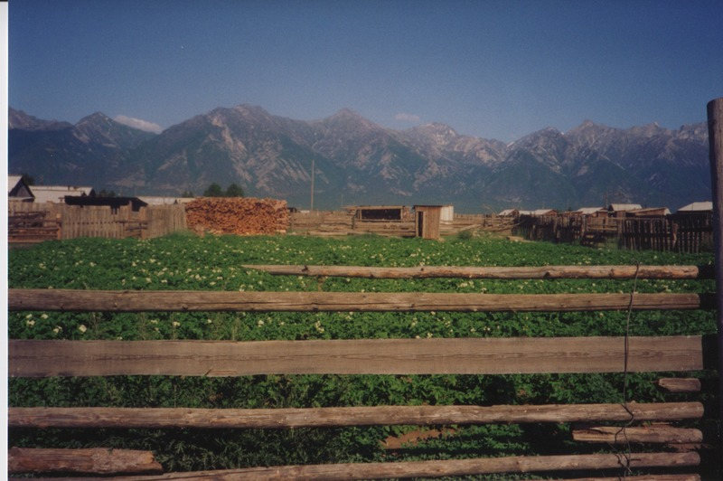

### identifier

6ad238f7-e2a3-4b4e-b053-9d848559dc8e

### creator

Humphrey, Caroline

### type

Image

### coverage

Bayangol

Khilgana

Karl Marx Collective

Buryatia

USSR

### description

Potato field.

### publisher

### source

Scanned from a print held in the archives of the Mongolia and Inner Asia Studies Unit, University of Cambridge.

### rights

### subject

### date

1993

### language

### contributor

### original filename

Humphrey-Buryatia-photos-2-23.png

### relation

### extent

3.3MiB

1799x1196 px

### format

image/png