Photograph of Handgate, Xinjiang by Tsui Yen Hu, 1993, No. 50

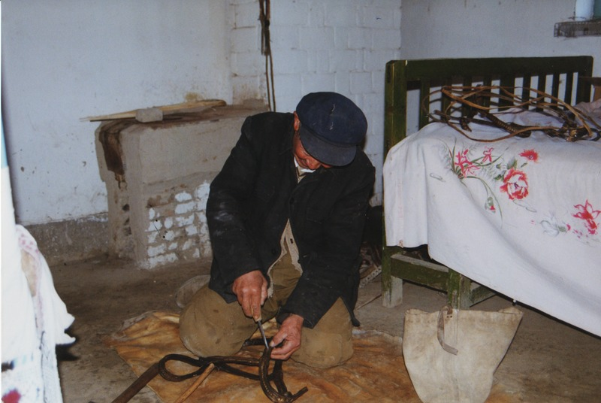

### identifier

6b01358e-ab99-4c30-adb8-a37764678559

### creator

Tsui Yen Hu

### type

Image

### coverage

Altai district

Handgate

PRC

Xinjiang

### description

Head of HH 8, a craftsman.

### publisher

### source

Scanned from colour print held in the archives of the University of Cambridge MacArthur Project "Environmental and Cultural Conservation in Inner Asia", Mongolia and Inner Asia Studies Unit.

### rights

### subject

research participants

### date

1993-05-19

### language

### format

image/png

### contributor

### original filename

TsuiYenHu-Handgate-1993-50.png

### relation

### extent

1777x1191 px

3.3 MiB