Vitafit factory tour image - 1pu3vhkd8rf4hhfqlldpgm9mt l

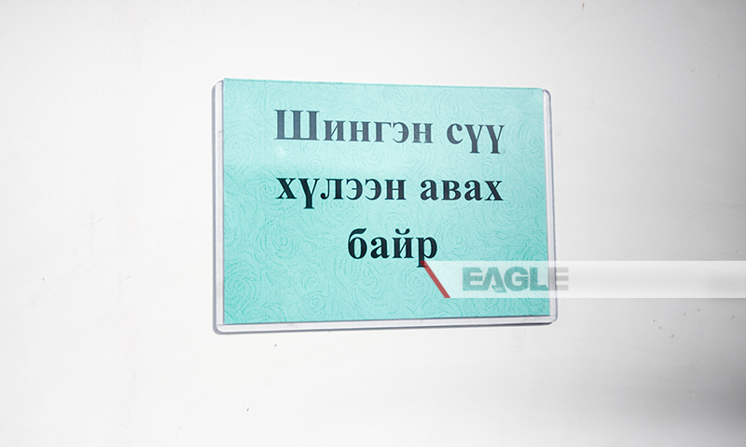

### identifier

6c29cb89-ecc2-4911-92a4-15150220292f

### creator

### type

Image

### coverage

Mongolia

### description

Goyo yogurt factory tour image published by Eagle.mn.

### publisher

### source

### rights

### subject

Mongolia

dairy

nationalism

social media

### date

2014

### language

Vitafit factory tour image - Vitafit factory tour image - 1pu3vhkd8rf4hhfqlldpgm9mt l

### format

image/jpeg

### original filename

1pu3vhkd8rf4hhfqlldpgm9mt_l.jpg

### extent

225.2 KiB

800x480 px

### modified

2014-03-24 18:29:02