6132

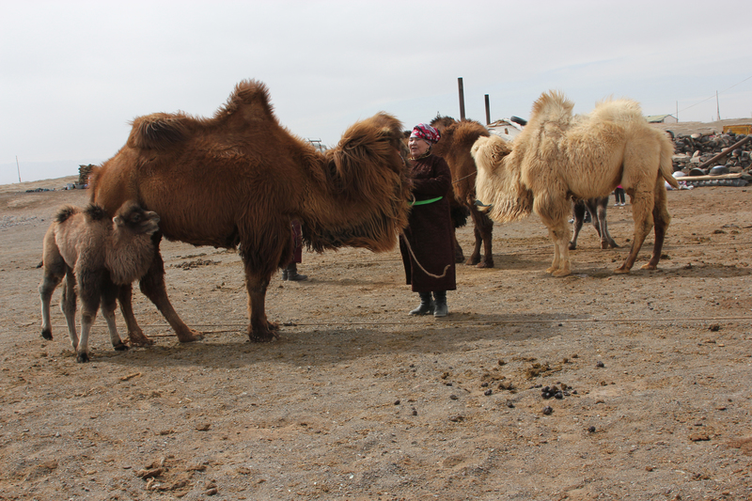

### identifier

6c6c55df-a563-409f-964e-85810867bdb7

### creator

Boldbaatar, Yu.

### type

Image

### coverage

Mongolia

Ömnögovi aimag

Khankhongor sum

### description

Coaxed mare-camel and its accepted new calf (Khankhongor Sooum, Umnugobi Province)

### publisher

### source

https://ich.unesco.org/img/photo/src/6132.jpg

### rights

### subject

### date

2011

### language

### original filename

06132.jpg

### extent

9.1 MiB

4500x3000 px

### format

image/jpeg

### modified

2012-12-05 02:28:25