Sending off and watering sheep at Khamar Monastery

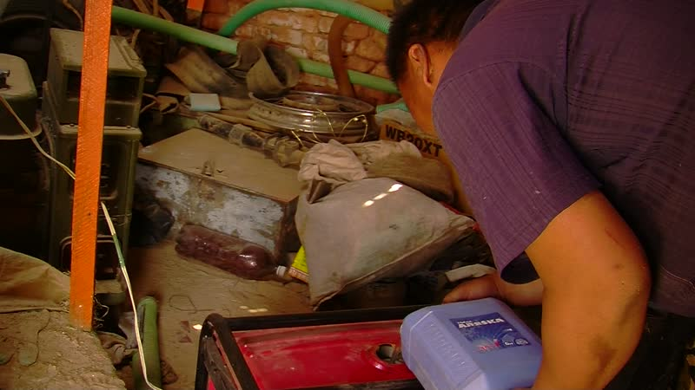

### identifier

6f734af1-c379-4858-b049-22593ac77762

### creator

Thrift, Eric

### type

Moving Image

### coverage

Mongolia

### description

The recordings in this series depict Sodnomtsog letting his sheep out of the enclosure, then driving them to the well next to his father's (Togtokh Lama's) elm plantation. He turns on the diesel pump at the well, and waters the livestock by filling the trough. He then sends the sheep off over the hill to graze to the south of the Monastery. Back at home, Chimgee sets out feed for the lambs and kids that have stayed behind.

### publisher

### source

### rights

### subject

Pastoralism Videos

Watering Livestock

Sodnomtsog

Dornogovi-Khamar Monastery

### date

2012-05-06

### language

### remote embed url

https://archive.org/embed/6f734af1-c379-4858-b049-22593ac77762

### format

inode/directory

### modified

2018-03-02 09:37:44

### original filename

PastoralismVideos--2012-05-06--WateringLivestock--Sodnomtsog--Dornogovi-KhamarMonastery.vclips

### table of contents

|  |  |  |
| --- | --- | --- |
| time | clip | description |
| 0:00:00 | 244 0314 01 |  |
| 0:13:53 | 244 0314 02 |  |
| 0:27:48 | 244 0314 03 |  |
| 0:41:42 | 244 0314 04 |  |
| 0:55:36 | 244 0314 05 |  |
| 1:01:59 | 244 0316 01 |  |