Image published in “Perestroika and the Pastoralists”

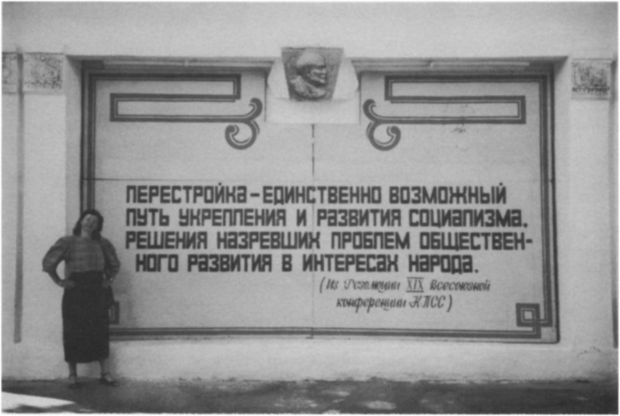

### identifier

70c1ae4b-be13-4b36-8be5-d70541b3cec4

### creator

Humphrey, Caroline

### type

Image

### coverage

Tuva

USSR

### description

The perestroika monument in Kyzyl, capital of Tuva ASSR. The monument reads in red lettering 'Perestroika is the single possible path to the strengthening and development of socialism, and to the solution of the impending problems of social development in the interests of the people (from the resolutions of the 19th All-Union Conference of the C.P. of the USSR)'. The relief at the top represents Lenin, the standing figure for on the the left posing photograph is Caroline Humphrey.

The perestroika monument in Kyzyl, capital of Tuva ASSR. The monument reads in red lettering 'Perestroika is the single possible path to the strengthening and development of socialism, and to the solution of the impending problems of social development in the interests of the people (from the resolutions of the 19th All-Union Conference of the C.P. of the USSR)'. The relief at the top represents Lenin, the standing figure for on the the left posing photograph is Humphrey, Caroline.

### publisher

Anthropology Today

### source

<https://www.jstor.org/stable/3032697>

Anthropology Today, vol. 5 no. 3, pp. 6--10

### rights

### subject

### date

2017-05-22 11:56:59

### language

### format

image/png

### original filename

at-article-figure_2.png

### extent

1596x1072 px

791.5 KiB