Map of Inner Asia (MONDEA)
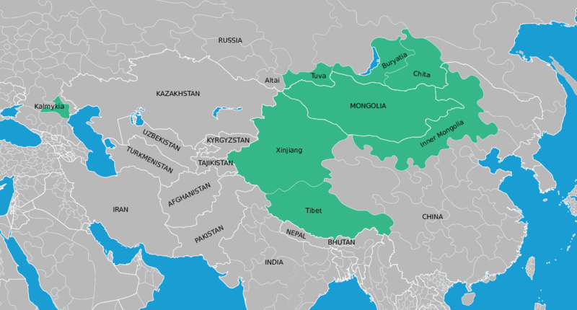

identifier
723ecbb5-d3a8-439b-81e1-42d76b3e0260

creator
Thrift, Eric

type
Image

coverage
Inner Asia

description
This map shows the Mongolian areas of Inner Asia that are represented in the Mongolian Digital Ethnography Archive.

publisher
Culture and Development Research Centre

source
Based on <https://commons.wikimedia.org/wiki/File:Blank_Map_World_Secondary_Political_Divisions.svg> and <https://commons.wikimedia.org/wiki/File:BlankMap-World6.svg>

rights
Public domain

subject
Inner Asia
maps

date
2017

language
English

original filename
Inner-Asia-MONDEA.svg

extent
6.6 MiB

format
image/svg+xml

modified
2017-10-08 18:42:07

