cover image for Losing Ground

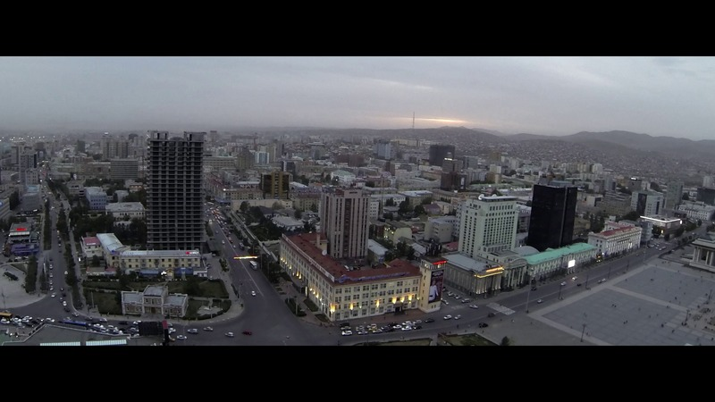

### identifier

737e2b4f-61b2-4486-889f-78053834ab98

### creator

Rappa, Bradley

### type

Image

### coverage

Mongolia

### description

Cover image for the film “Losing Ground”

### publisher

### source

### rights

### subject

### date

2014

### language

### format

image/png

### contributor

### original filename

losing-ground-cover.png

### relation

### extent

348.7KiB

800x450 px