Photographs of Dashbalbar sum, No. 28

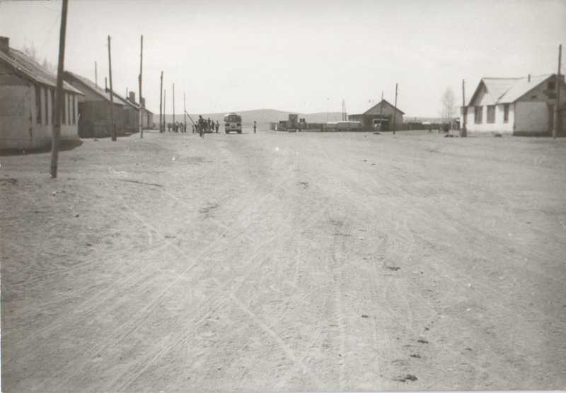

### identifier

7476aaeb-c21a-47df-9586-6f47f255c1a2

### creator

Batbuyan B.

### type

Image

### coverage

Dashbalbar sum

Dornod aimag

Mongolia

### description

Every two weeks the coach-bus arrived, this being the main link between the sum centre and the aimag centre. But in July 1993 the service stopped.

### publisher

### source

Scanned from a photographic print held in the archives of the Mongolia and Inner Asia Studies Unit, University of Cambridge.

### rights

### subject

transportation

### date

1992

### language

### format

image/png

### contributor

### original filename

bair-batbuyan-photos-28.png

### relation

### extent

1513x1051 px

2.2 MiB