“Гоё тараг”, “Зөв аарцны ундаа” Хятадад савлагдаж байна уу?

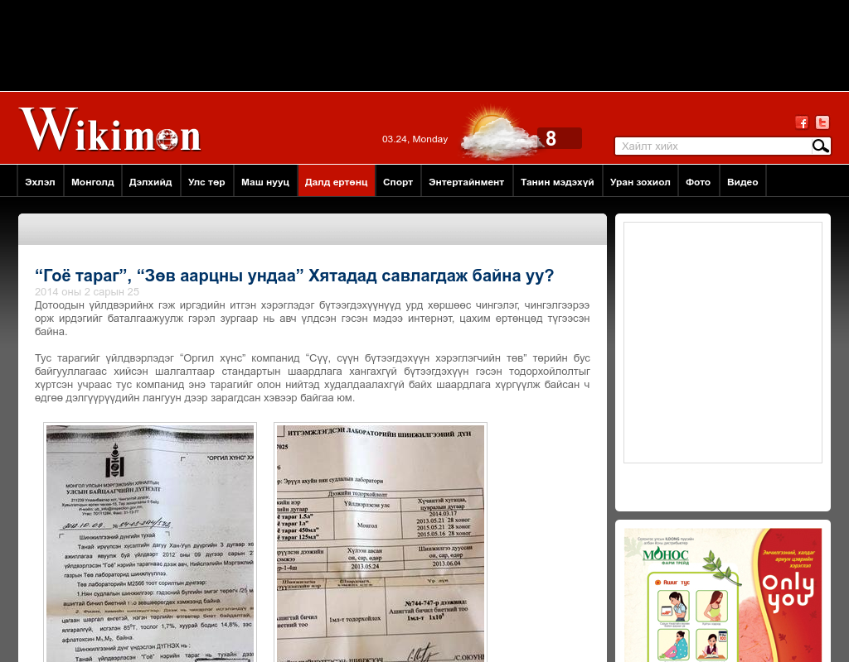

### identifier

74e48bba-760c-47e8-ae28-4a5f1dacf94d

### creator

### type

Text

### coverage

Mongolia

### description

### publisher

### source

http://www.wikimon.mn/content/53065.shtml

### rights

### subject

Mongolia

dairy

nationalism

social media

### date

24 Mar 2014 14:37:37

### language

Mongolian

### format

text/plain

### modified

2018-01-11 14:12:43

### original filename

wikimon.mn.Goyo_tarag.url

### extent

41.0 B