Image published in “Perestroika and the Pastoralists”

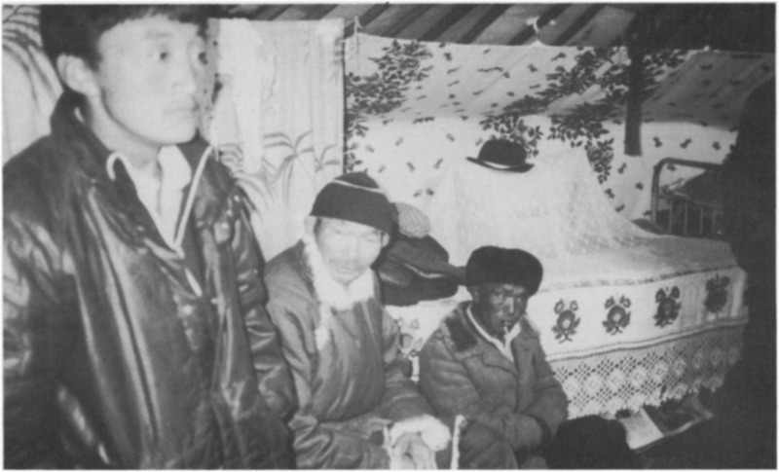

### identifier

75ef95a2-9662-4d91-9bd3-2cdc2ce2b3b0

### creator

Humphrey, Caroline

### type

Image

### coverage

Tuva

USSR

### description

Herdsmen at a brigade meeting to confirm winter pastures.

### publisher

Anthropology Today

### source

<https://www.jstor.org/stable/3032697>

Anthropology Today, vol. 5 no. 3, pp. 6--10

### rights

### subject

### date

2017-05-22 11:56:58

### language

### format

image/png

### original filename

at-article-figure_1.png

### extent

1777x1077 px

995.4 KiB