Mongolia I—On the Edge of the Gobi

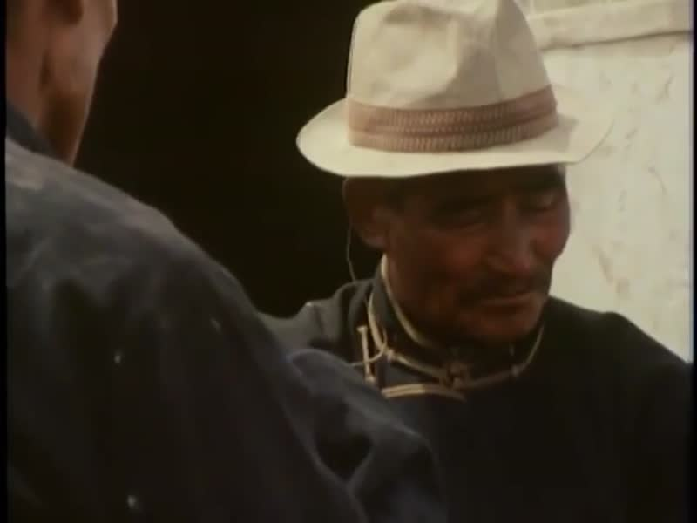

### identifier

7605e345-823b-4f78-b734-0f5e72538c12

### creator

Lattimore, Owen

Moser, Brian

### type

Moving Image

### coverage

Mongolia

### description

Mongolia is a country the size of Western Europe with under 1.5 million people but over 23 million head of livestock. This film concentrates on life in the great plains of Mongolia, at the foot of the Altai mountains, where the ancient skills of the Mongol horsemen coexist with the new methods of the socialist revolution of 1921 which brought collective farming to the steppes. Professor Owen Lattimore, who serves as commentator, is the West's leading authority on Mongolia; he first crossed the Gobi in 1926. The Granada film crew were the first documentary unit allowed in from the West, during summer 1974 and winter 1975.

### publisher

Granada Television

### source

### rights

### subject

herding

social change

rural life

### date

1975

### language

English

### contributor

### original filename

Mongolia I—On the Edge of the Gobi.mp4

### relation

### extent

264.6 MiB

3094.640000

### format

video/mp4

### modified

2017-05-25 03:59:32

### remote embed url

### public

FALSE