Photograph of Handgate, Xinjiang by Tsui Yen Hu, 1993, No. 21

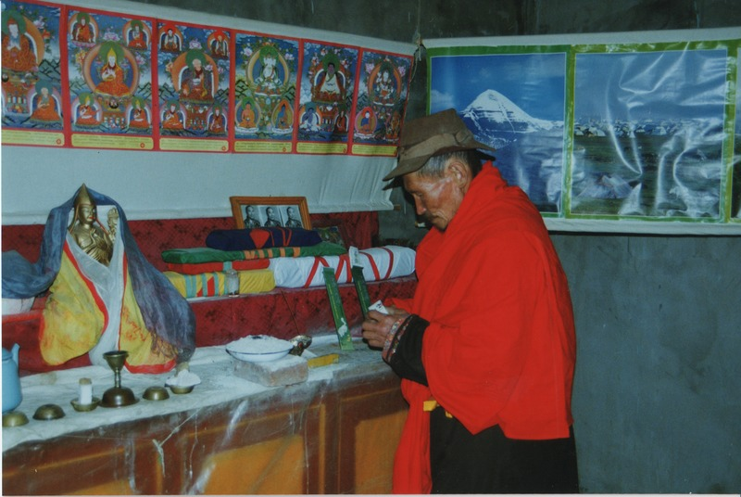

### identifier

761f04a0-cc78-46c4-8d02-018f84f481af

### creator

Tsui Yen Hu

### type

Image

### coverage

Altai district

Handgate

PRC

Xinjiang

### description

Lama Øbuden praying, Handgate Temple. The image on the left is said to be three hundred years old.

### publisher

### source

Scanned from colour print held in the archives of the University of Cambridge MacArthur Project "Environmental and Cultural Conservation in Inner Asia", Mongolia and Inner Asia Studies Unit.

### rights

### subject

Buddhism

### date

1993-05-08

### language

### format

image/png

### contributor

### original filename

TsuiYenHu-Handgate-1993-21.png

### relation

### extent

1777x1191 px

3.4 MiB