Тэсо ХХК - Милко - Тослог сүү

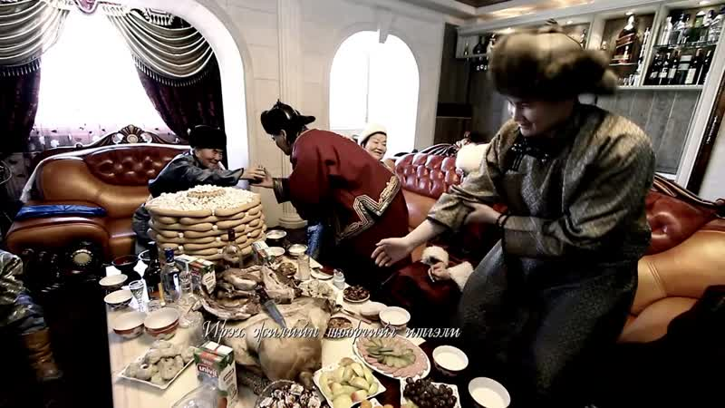

### identifier

78579fe4-1260-4718-904b-ffd8f020ab7f

### creator

TESO LLC

### type

Moving Image

### coverage

### description

TV commercial for Teso high-fat milk

### publisher

### source

<http://youtu.be/LoKym6u9t70>

### rights

### subject

Mongolia

Dairy Production

Milk Marketing

Television Commercials

### date

2011-03-24 14:00:36

### language

### format

video/mp4

### modified

2014-02-04 01:55:34

### extent

7.1 MiB

19.520000