Oral history interview No. 080810B with Sugir (b. 1963): transcript

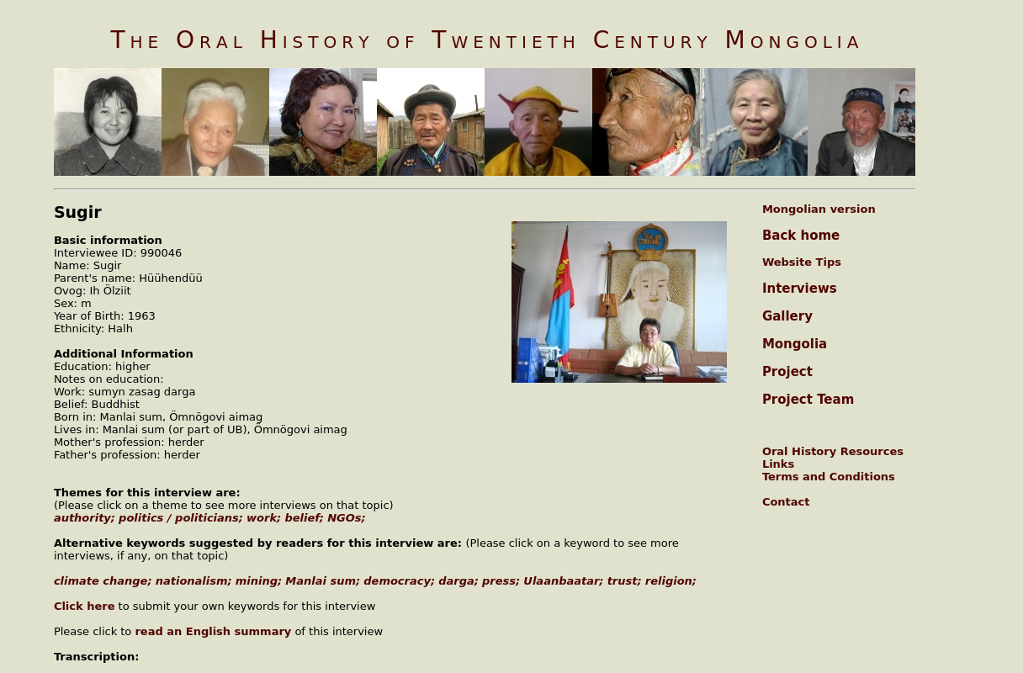

### identifier

7858b6a8-e541-4bf6-ac38-a64d0b18dbea

### creator

Sugir

### type

Text

### coverage

### description

### publisher

Oral History of Twentieth Century Mongolia

### source

<http://amantuuh.socanth.cam.ac.uk/search/view_transcript.php?Interview=080810B>

### rights

Copyright MIASU. Reproduced with permission. Brief excerpts from interviews and other material may be used in academic or popular work for non-commercial purposes provided proper attribution and credit is given to the Oral History of Twentieth Century Mongolia and the Mongolia and Inner Asia Studies Unit (MIASU). You must not: (a) republish this material (including republication on another website) without the express written permission of MIASU; (b) sell, rent or sub-license material from the website; (c) show any material from the website in public without attribution to The Oral History of Twentieth Century Mongolia; (d) reproduce, duplicate, copy or otherwise exploit material on the website for a commercial purpose without express written permission; (e) use the material in any way that is damaging to the project or any of the persons named in the interviews. See <http://amantuuh.socanth.cam.ac.uk/terms.php> for details.

### subject

### date

2008

### language

Mongolian

### format

text/plain

### contributor

Oyuntungalag

### original filename

080810B-Sugir-transcript.url

### relation

5299e029-ea96-4afc-8bb9-0618b338aeb7

### extent

79.0 B