Photograph of Handgate, Xinjiang by Tsui Yen Hu, 1993, No. 26

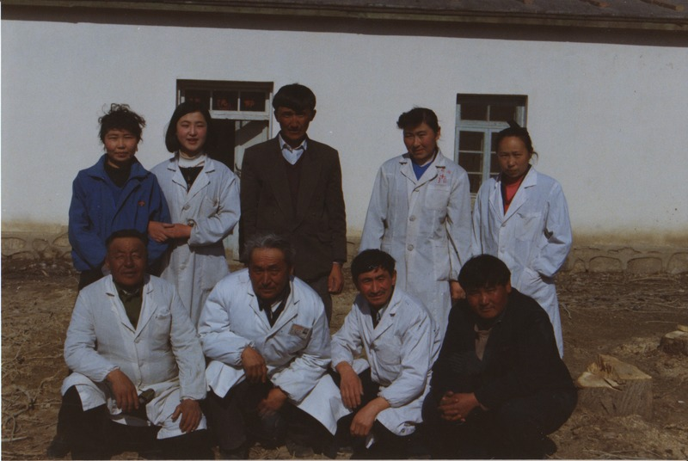

### identifier

7b82294b-2d78-4bf1-a593-df6e9af03842

### creator

Tsui Yen Hu

### type

Image

### coverage

Altai district

Handgate

PRC

Xinjiang

### description

Doctors and nurses of Handgate hospital

### publisher

### source

Scanned from colour print held in the archives of the University of Cambridge MacArthur Project "Environmental and Cultural Conservation in Inner Asia", Mongolia and Inner Asia Studies Unit.

### rights

### subject

medicine

### date

1993-04-17

### language

### format

image/png

### contributor

### original filename

TsuiYenHu-Handgate-1993-26.png

### relation

### extent

1777x1191 px

3.3 MiB