Caroline Humphrey - Buryatia photos - No. 3-01

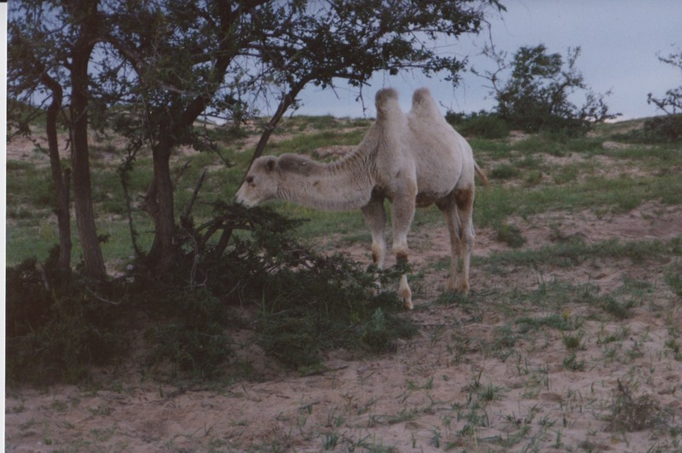

### identifier

7d03b99f-d45f-427c-90ad-36551d771eef

### creator

Humphrey, Caroline

### type

Image

### coverage

Khargant

### description

Camel eating vegetation.

### publisher

### source

Scanned from a print held in the archives of the Mongolia and Inner Asia Studies Unit, University of Cambridge.

### rights

### subject

### date

1993

### language

### contributor

### original filename

Humphrey-Buryatia-photos-3-01.png

### relation

### extent

3.4MiB

1799x1196 px

### format

image/png