Photograph from Govisumber, No. 15

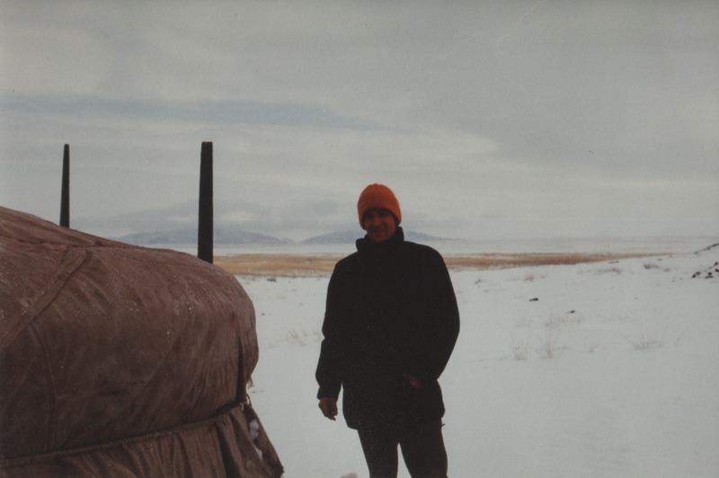

### identifier

7e2e27d7-f7fd-4424-8f8e-6e34e6c6adbf

### creator

Sneath, David

### type

Image

### coverage

Govisumber aimag

Mongolia

### description

### publisher

### source

scanned from a photographic print held in the archives of the Mongolia and Inner Asia Studies Unit, University of Cambridge

### rights

### subject

anthropologists in the field

### date

1995

### language

### format

image/png

### contributor

### original filename

sneath-govisumber_15.png

### relation

### extent

1776x1182 px

3.1MiB