Prostitution and the Transformation of the Chinese Trading Town of Ereen

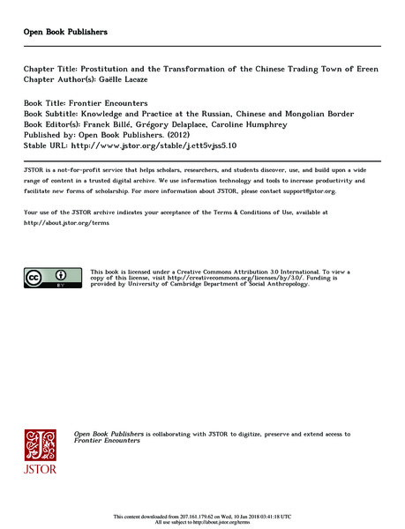

### identifier

7ef5ba95-f783-443b-a621-804e317c9f1e

### creator

Lacaze, Gaëlle

### type

Text

### coverage

Ereen

PRC

Zamyn üüd

Mongolia

### description

This chapter first examines the transformation of Ereen from 2007 to 2010. The main changes are the construction of “New Ereen” in the western section of the city; the opening in the south of two huge supermarkets, as large as an entire block, dedicated to construction materials; and the sculptures of dinosaurs, in the southwest, past the city gates on the road to Beijing. These changes are a good illustration of the local government’s main political goals with regard to the city’s development. I then examine how the appropriation of the city by Mongolian migrants underlines differential postures in terms of gender, social status and economic power. It sheds light on a new kind of nomadic activity developed by Mongols who have appropriated for themselves the political management of the city. I conclude with an analysis of the daily life of several Mongolian prostitutes. The type of sex work found in the city of Ereen reveals the contemporary strategies of some Mongolian women.

### publisher

Open Book Publishers

### source

Franck Billé, Grégory Delaplace, and Caroline Humphrey, editors. Frontier Encounters: Knowledge and Practice at the Russian, Chinese and Mongolian Border. Open Book Publishers, 2012. Pages 111--135.

<http://www.jstor.org/stable/j.ctt5vjss5.10>

### rights

This book is licensed under a Creative Commons Attribution 3.0 International license.

<http://creativecommons.org/licenses/by/3.0/>

### subject

Prostitution

Border cities

Urbanization

### date

2012

### language

English

### original filename

Lacaze2012.pdf

### extent

5.3 MiB

### contributor

University of Cambridge Department of Social Anthropology

### format

application/pdf

### modified

2018-01-09 21:43:11