Annual festival at Khamar Monastery

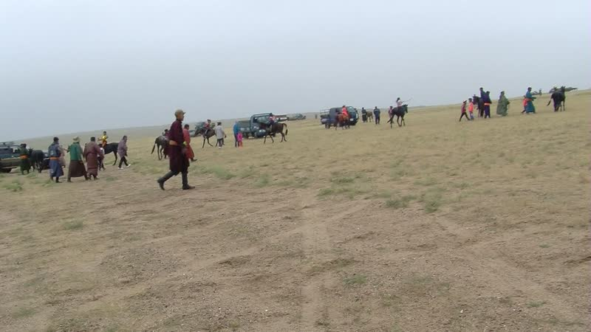

### identifier

812ac253-92e6-454d-bd7d-b34bfbc5c618

### creator

Thrift, Eric

### type

Moving Image

### coverage

Mongolia

### description

This series of recordings documents outdoor events at the annual festival held at Khamar Monastery on September 10.

### publisher

### source

### rights

### subject

Pastoralism Videos

Naadam

Horse Racing

Dornogovi-Khamar Monastery

### date

2012-09-10

### language

### format

inode/directory

### modified

2018-03-02 09:37:44

### original filename

PastoralismVideos--2012-09-10--Naadam--HorseRacing--Dornogovi-KhamarMonastery.vclips

### table of contents

|  |  |  |
| --- | --- | --- |
| time | clip | description |
| 0:00:00 | 300G0136 01 |  |
| 0:00:31 | 300G0137 01 |  |
| 0:07:19 | 300G0138 01 |  |
| 0:08:36 | 300G0139 01 |  |
| 0:09:27 | 300G0140 01 |  |
| 0:16:16 | 300G0141 01 |  |
| 0:20:03 | 300G0142 01 |  |
| 0:23:10 | 300G0143 01 |  |
| 0:33:21 | 300G0144 01 |  |
| 0:35:54 | 300G0145 01 |  |
| 0:46:43 | 300G0146 01 |  |
| 0:49:11 | 300G0147 01 |  |
| 0:56:18 | 300G0148 01 |  |
| 0:57:57 | 300G0149 01 |  |
| 1:01:26 | 300G0150 01 |  |
| 1:03:18 | 300G0151 01 |  |
| 1:05:47 | 300G0152 01 |  |
| 1:19:41 | 300G0152 02 |  |
| 1:21:55 | 300G0153 01 |  |
| 1:35:49 | 300G0153 02 |  |
| 1:41:08 | 300G0154 01 |  |
| 1:41:09 | 300G0155 01 |  |
| 1:41:40 | 300G0156 01 |  |
| 1:44:44 | 300G0157 01 |  |
| 1:46:14 | 300G0158 01 |  |
| 1:47:42 | 300G0159 01 |  |
| 1:49:24 | 300G0160 01 |  |
| 1:53:17 | 300G0161 01 |  |
| 1:53:33 | 300G0162 01 |  |
| 2:07:26 | 300G0162 02 |  |
| 2:21:20 | 300G0162 03 |  |
| 2:22:19 | 300G0163 01 |  |
| 2:23:35 | 300G0164 01 |  |
| 2:37:29 | 300G0164 02 |  |
| 2:51:23 | 300G0164 03 |  |
| 3:05:17 | 300G0164 04 |  |