Goyo Tarag

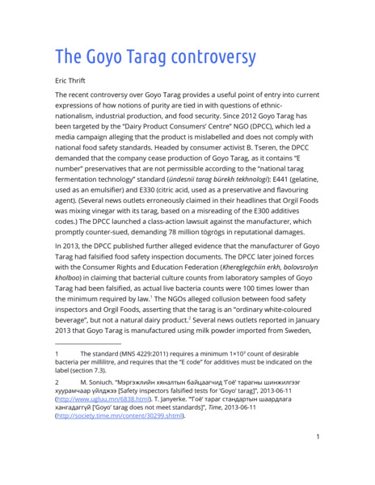

### identifier

829a31a2-a84e-459f-b73e-a71f537ce15e

### creator

Thrift, Eric

### type

Text

### coverage

Mongolia

### description

SUMMARY: In February 2014, a pair of blurry images taken at the railway station in Ulaanbaatar began to make the rounds of Facebook in Mongolia. These images, taken by a bystander using his mobile phone, purported to show two men next to a train box car, unloading crates of Goyo Tarag – a yogurt drink produced by Orgil Foods, subsidiary of the major Mongolian drinks manufacturer Vitafit. What seemed out of place was that the train had, apparently, just arrived from the southern border: if this was a Mongolian beverage, why was it being unloaded from a train bringing goods imported from China? Given that Mongolia is a nation of nomadic pastoralists with 45 million livestock, it seemed a national affront, and a major food security concern, that milk products should be imported – and from China, of all places! Within two days, the photographs had been “liked”, commented upon, shared, and re-shared by hundreds of Mongolians. Very soon they had been republished by several newspapers and online news sites, where they provoked commentary from an increasingly wide audience. Reactions to the photographs ranged from surprise and shock to anger and distress. While some commenters questioned the authenticity of the photographs, many acknowledged a troubling, yet perfectly credible, explanation: the manufacturers of this beverage had been misleading the public, by having their commodity produced inexpensively in China and falsely labelled to indicate local origin. As interest in the photographs spread, mainstream news outlets began to report on them widely.

### publisher

### source

### rights

### subject

Mongolia

dairy

nationalism

social media

### date

2015

### language

English

### format

application/octet-stream

### original filename

goyo-tarag.docx

### extent

4.4 MiB

### modified

2018-03-23 16:33:31