Studies In Frontier History: Collected Papers, 1928-1958

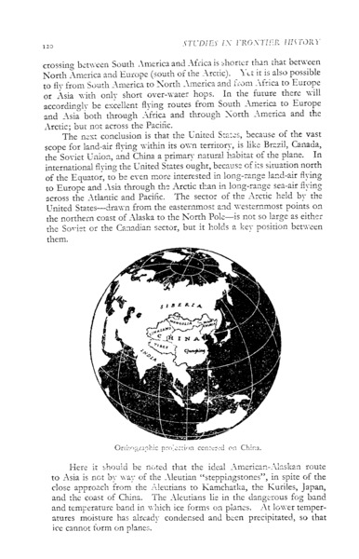

### identifier

835ed2ba-703e-4b6b-bfca-617c2048b993

### creator

Lattimore, Owen

### type

Text

### coverage

Mongolia

China

Turkmenistan

Inner Asia

### description

Collection of essays on the history of Inner Asia as a “frontier” region, addressing the relationship between nomadic and sedentary peoples. Sections: (1) The Inner Asian Frontier; (2) Sinkiang; (3) Mongolia; (4) Manchuria and China; (5) National Minorities; (6) Social History

### publisher

Oxford University Press

### source

### rights

### subject

Inner Asia

### date

1962

### language

English

### contributor

### original filename

Studies-In-Frontier-History-Collected-Papers-1928-1958.pdf

### relation

### extent

31.9 MiB

### format

application/pdf

### modified

2017-05-29 12:12:48

### remote embed url

https://archive.org/stream/studiesinfrontie017780mbp?ui=embed

### public