Caroline Humphrey Mongolia Super8 film no. 18

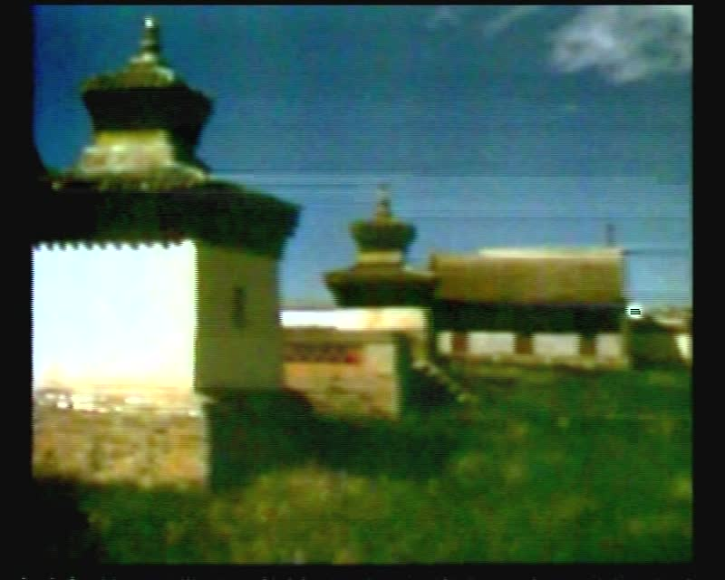

### identifier

84d7eaa7-6c1f-4f33-9258-1ba9f953bc7d

### creator

Humphrey, Caroline

### type

Moving Image

### coverage

Erdene-Zuu Monastery

Mongolia

### description

Erdene-Zuu (good)

### publisher

MIASU

### source

Digitized from a VCR transfer tape held at the Mongolia and Inner Asia Studies Unit, University of Cambridge

### rights

Copyright Caroline Humphrey

### subject

monasteries

### date

ca. 1970s

### language

None

### original filename

humphrey-super8-mongolia-18.mp4

### extent

993.7 MiB

217.238000

### format

video/mp4

### modified

2017-06-16 11:11:51

### alternate url

https://archive.org/embed/84d7eaa7-6c1f-4f33-9258-1ba9f953bc7d