Oral history interview No. 090804A with Dolgorjav (b. 1942): translation

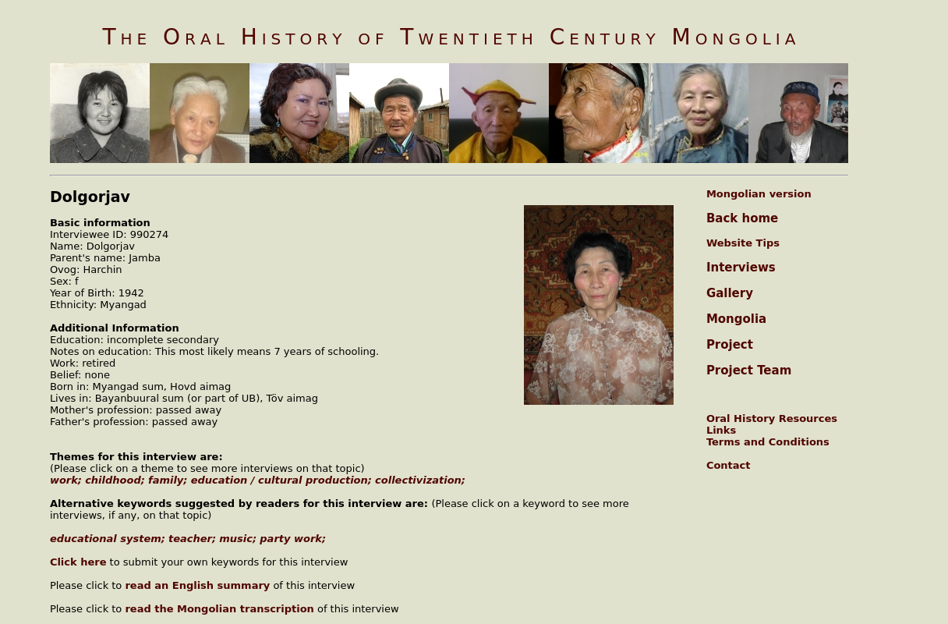

### identifier

85ffc7fd-fe63-4a7d-b9e0-7940c8c73f7d

### creator

Dolgorjav

### type

Text

### coverage

Mongolia

Töv aimag

### description

Oral history interview with Jamba Dolgorjav.

### publisher

Oral History of Twentieth Century Mongolia

### source

<http://amantuuh.socanth.cam.ac.uk/search/view_trans.php?Interview=090804A>

### rights

Copyright MIASU. Reproduced with permission. Brief excerpts from interviews and other material may be used in academic or popular work for non-commercial purposes provided proper attribution and credit is given to the Oral History of Twentieth Century Mongolia and the Mongolia and Inner Asia Studies Unit (MIASU). You must not: (a) republish this material (including republication on another website) without the express written permission of MIASU; (b) sell, rent or sub-license material from the website; (c) show any material from the website in public without attribution to The Oral History of Twentieth Century Mongolia; (d) reproduce, duplicate, copy or otherwise exploit material on the website for a commercial purpose without express written permission; (e) use the material in any way that is damaging to the project or any of the persons named in the interviews. See <http://amantuuh.socanth.cam.ac.uk/terms.php> for details.

### subject

childhood

collectivization

education

family

oral history

work

### date

2009

### language

English

### format

text/plain

### contributor

Baasanhüü

### original filename

090804A-Dolgorjav-translation.url

### relation

2c16a320-2a53-4dff-a1c1-f7ff16d73f80

### extent

74.0 B