Original typed captions for photographs supplied by Tsui Yen Hu

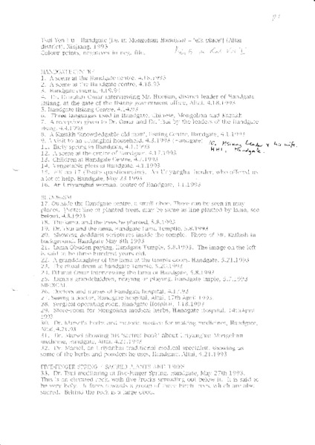

### identifier

8622b12a-71b6-422d-9f77-189ba098d489

### creator

Tsui Yen Hu

### type

Text

### coverage

Altai district

Handgate

PRC

Xinjiang

### description

List of photographs taken and submitted by Tsui Yen Hu.

### publisher

### source

Scanned from printed document held in the archives of the University of Cambridge MacArthur Project "Environmental and Cultural Conservation in Inner Asia", Mongolia and Inner Asia Studies Unit.

### rights

### subject

### date

1993

### language

### format

application/pdf

### contributor

### original filename

Tsui-captions.pdf

### relation

### extent

306.0KiB