Introduction: The concept of Inner Asia

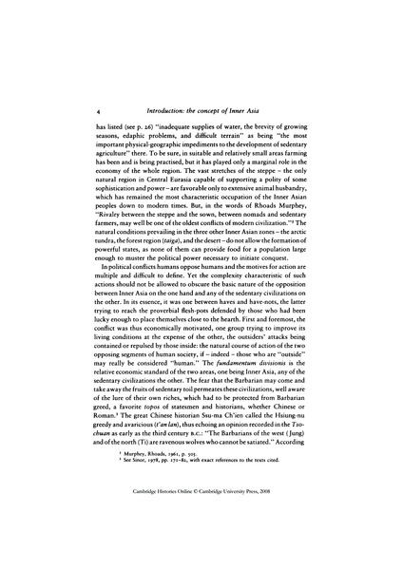

### identifier

8796db86-b526-4e7c-bcdf-d8f025ed82f6

### creator

Sinor, Denis

### type

Text

### coverage

Inner Asia

### description

If the continents of Europe and Asia are conceptual entities, Eurasia - the combined land mass of the two - is a physiogeographical one. Each of the sedentary civilizations - in loose terminology Europe, the Middle East, India, Southeast Asia and East Asia - is a unique combination of cultural features. Some of these may appear in more than one area; yet an association of various components, moulded by a unique historical process and greatly influenced by national environment, made each of these regions different from the others. The frontier of Inner Asia is unstable; it has varied from age to age, shifting according to the balance of power between its own population and that of the surrounding, sedentary civilizations. The military efficiency of a nomad cavalry force was a function of its size, but the relationship between the number of horses and their military value was not a mathematical constant but a geometric progression.

### publisher

Cambridge University Press

### source

<https://doi.org/10.1017/CHOL9780521243049.002>

Sinor, Denis, ed. The Cambridge history of early Inner Asia. Vol. 1. Cambridge University Press, 1990.

### rights

Copyright Cambridge University Press

### subject

Inner Asia

cultural ecology

history

### date

1990

### language

English

### original filename

Sinor1990.pdf

### extent

1.4 MiB

### format

application/pdf

### modified

2013-02-06 05:48:29