Photograph from Inner Mongolia, No. 11

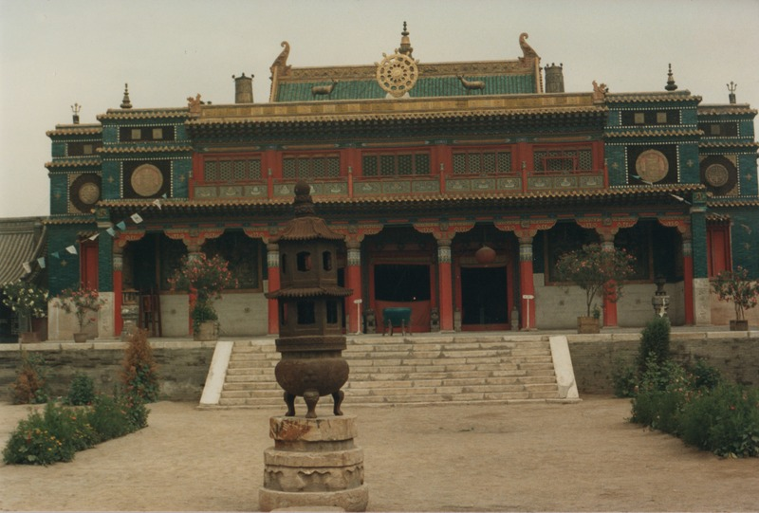

### identifier

89caae3c-3ce3-49af-b4f7-f2074f186733

### creator

Sneath, David

### type

Image

### coverage

Inner Mongolia

PRC

### description

The monastery at Xilin Xot, Xilingol aimag. David Sneath spent about two hours drinking large bowls of cold camel airag (chegee?) with about a dozen older men, who explained they were former monks who had survived the cultural revolution. The men were forced into short-lasted producer cooperatives, then subsequently persecuted.

### publisher

### source

Scanned from a photographic print held in the archives of the Mongolia and Inner Asia Studies Unit, University of Cambridge.

### rights

### subject

monasteries

### date

ca. 1988

### language

### original filename

sneath-inner-mongolia-1980s.png_11.png

### relation

### extent

3.1 MiB

1747x1182 px

### contributor

### format

image/png

### modified

2017-05-25 11:04:18