Photographs of Dashbalbar sum, No. 34

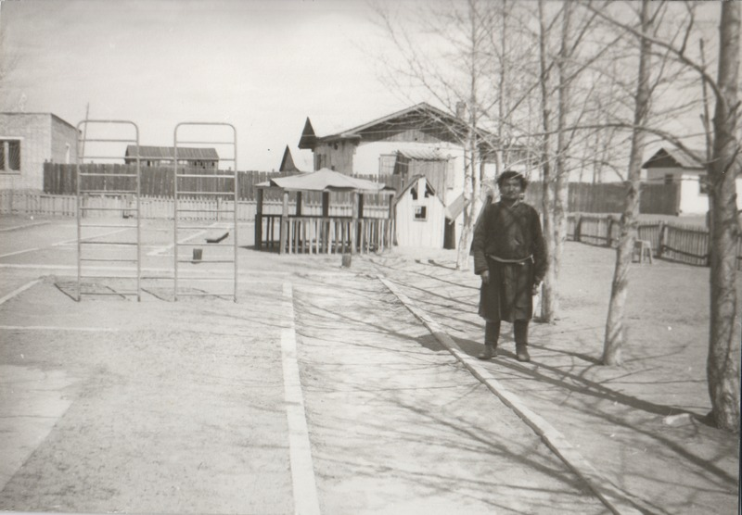

### identifier

8ea27d4e-6b96-4630-b304-fbee2319f718

### creator

Batbuyan B.

### type

Image

### coverage

Dashbalbar sum

Dornod aimag

Mongolia

### description

Watchman at Dashbalbar sum kindergarten

### publisher

### source

Scanned from a photographic print held in the archives of the Mongolia and Inner Asia Studies Unit, University of Cambridge.

### rights

### subject

schools

### date

ca. 1993

### language

### format

image/png

### contributor

### original filename

bair-batbuyan-photos-34.png

### relation

### extent

1504x1045 px

2.2 MiB