Photographs from Barguzin, No. 08

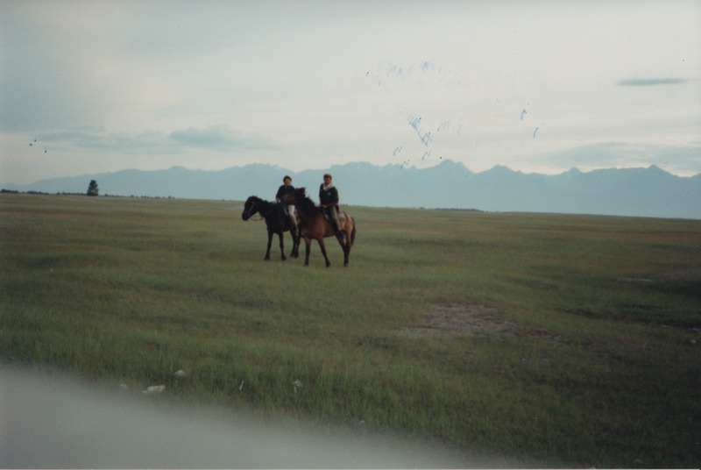

### identifier

8f7501c0-bd6a-4b14-82f0-441ba985cd49

### creator

Gomboev, Bair

### type

Image

### coverage

Barguzin

Burtyatia

Russian Federation

### description

Argada village, summer pastures, medium productivity.

### date

1993-07

### language

### format

image/png

### modified

2017-05-25 10:02:59

### original filename

bair-batbuyan-photos-08.png

### source

Scanned from a photographic print held in the archives of the Mongolia and Inner Asia Studies Unit, University of Cambridge

### extent

2.7 MiB

1777x1191 px

### subject

rangeland