6131

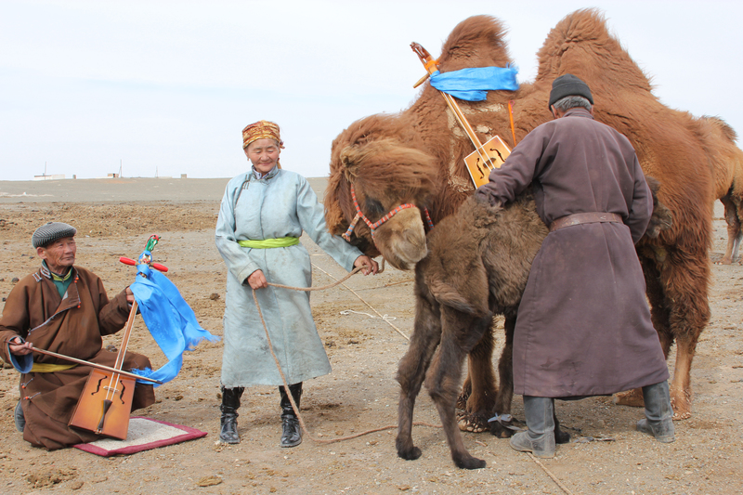

### identifier

9047cc6d-6ad8-46c6-b6e3-2140bc68bffb

### creator

Boldbaatar, Yu.

### type

Image

### coverage

Mongolia

Ömnögovi aimag

Khankhongor sum

### description

The mare-camel is accepting the orphan calf (Khankhongor Sooum, Umnugobi Province)

### publisher

### source

https://ich.unesco.org/img/photo/src/6131.jpg

### rights

### subject

### date

2011

### language

### original filename

06131.jpg

### extent

8.0 MiB

4500x3000 px

### format

image/jpeg

### modified

2012-12-05 02:28:25