Caroline Humphrey - Buryatia photos - No. 3-08

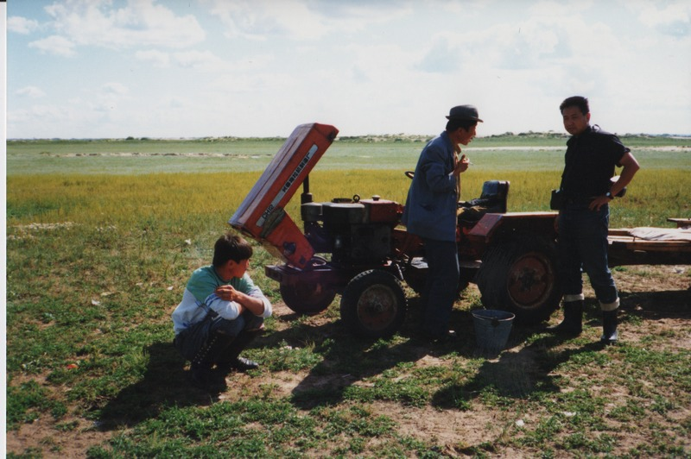

### identifier

90600e83-7d2b-42a6-bb5f-0b3c2c1d00b4

### creator

Humphrey, Caroline

### type

Image

### coverage

Khargant

### description

### publisher

### source

Scanned from a print held in the archives of the Mongolia and Inner Asia Studies Unit, University of Cambridge.

### rights

### subject

### date

1993

### language

### extent

3.4MiB

1799x1196 px

### contributor

### original filename

Humphrey-Buryatia-photos-3-08.png

### relation

### format

image/png