Photographs from Barguzin, No. 16

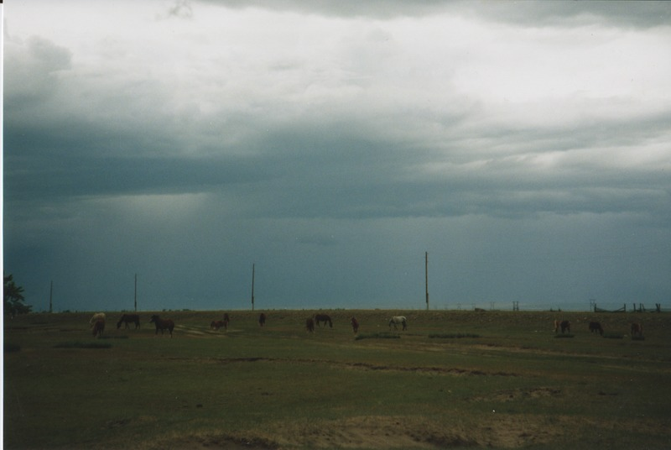

### identifier

90b22f5b-0bae-4d67-b1fc-49a3d2a5e2e0

### creator

Gomboev, Bair

### type

Image

### coverage

Barguzin

Burtyatia

Russian Federation

### description

Summer pastures, close to the road at Bayangol selsoviet, Barguzin.

### date

1993-07

### language

### format

image/png

### modified

2017-05-25 02:10:30

### original filename

bair-batbuyan-photos-16.png

### source

Scanned from a photographic print held in the archives of the Mongolia and Inner Asia Studies Unit, University of Cambridge

### extent

3.0 MiB

1777x1191 px

### subject

rangeland