Map of Evariste Huc’s travels

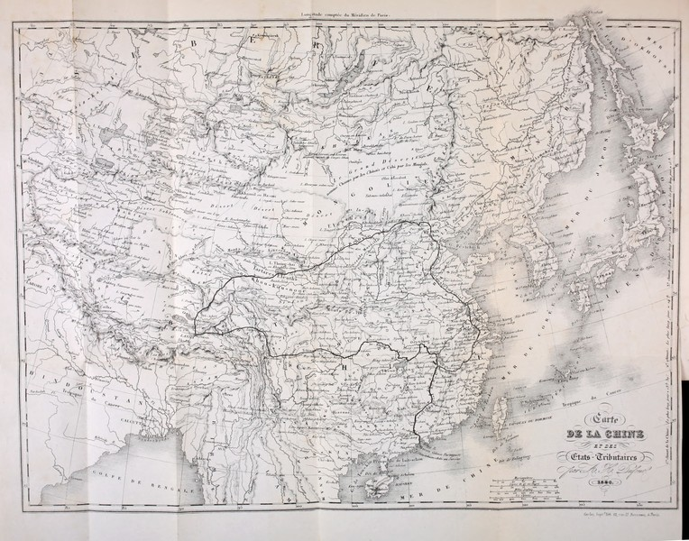

### identifier

9176c850-1175-4ec5-bd9e-93df4f59362c

### creator

Dufour, H

### type

Image

### coverage

Inner Mongolia

Mongolia

PRC

### description

Map accompanying “Souvenirs d'un voyage dans la Tartarie, le Thibet et la Chine”, Evariste Huc, 1850

### publisher

### source

Souvenirs d'un voyage dans la Tartarie, le Thibet et la Chine, Evariste Huc, 1850

<http://archive.org/details/souvenirsdunvoya01huce>

<https://commons.wikimedia.org/wiki/File:Evariste_Huc_carte_voyage.jpg>

### rights

Public domain

### subject

expeditions

maps

### date

1850

### language

French

### format

image/jpeg

### modified

2017-10-09 12:41:51

### original filename

Evariste_Huc_carte_voyage.jpg

### extent

2.1 MiB

3559x2794 px