Stone merchant

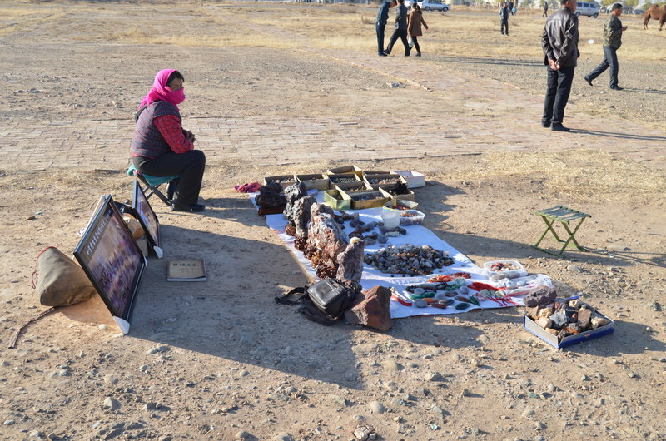

### identifier

917fcd24-a725-4ec3-9c6c-68ed5b4b7730

### creator

White, Thomas

### type

Image

### coverage

Alashan

Inner Mongolia

PRC

### description

A woman selling stones collected from the desert, laid out on a sheet and in boxes on the ground. Stones with natural shapes resembling people, objects, or animals are considered auspicious and in demand by Chinese buyers.

### publisher

### source

Image submitted by the author.

### rights

Copyright Thomas White. All rights reserved. Please contact the author for information on re-use.

### subject

camels

### date

2013-11-08 02:43:42

### language

### format

image/jpeg

### contributor

### original filename

DSC_0059.JPG

### relation

### extent

4.1MiB

4928x3264 px