Caroline Humphrey - Buryatia photos - No. 2-13

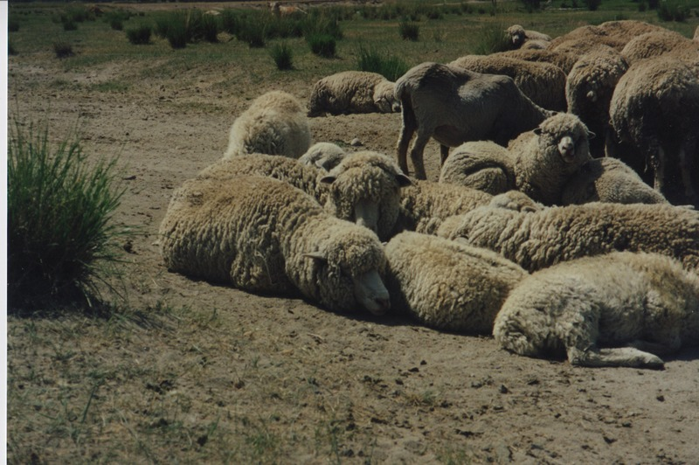

### identifier

92db0258-86c1-477b-8d04-8cc7e9e7983e

### creator

Humphrey, Caroline

### type

Image

### coverage

Bayangol

Khilgana

Karl Marx Collective

Buryatia

USSR

### description

Sheep.

### publisher

### source

Scanned from a print held in the archives of the Mongolia and Inner Asia Studies Unit, University of Cambridge.

### rights

### subject

### date

1993

### language

### contributor

### original filename

Humphrey-Buryatia-photos-2-13.png

### relation

### extent

3.5MiB

1799x1196 px

### format

image/png