Dolgorsüren distilling milk liquor (shimiin arkhi)

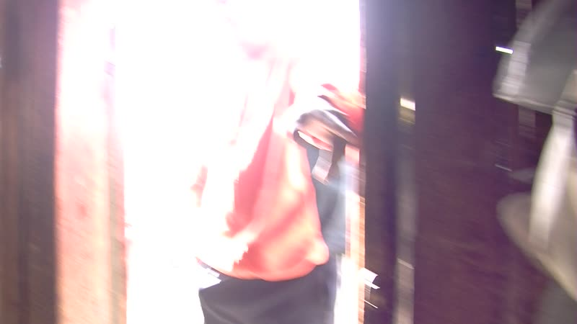

### identifier

935255c3-98be-428e-8976-04bc74372c5a

### creator

Thrift, Eric

### type

Moving Image

### coverage

Mongolia

Selenge aimag

Yeröö sum

### description

The recordings in this series depict Dolgorsüren distilling milk liquor, while her daughter-in-law prepares jars for strawberry jam making.

### publisher

### source

### rights

### subject

Pastoralism Videos

Distilling Milk Liquor

Making Strawberry Jam

Dolgorsuren

### date

2012-07-15

### language

### format

inode/directory

### modified

2018-03-02 09:37:44

### original filename

PastoralismVideos--2012-07-15--DistillingMilkLiquor--MakingStrawberryJam--Dolgorsuren--Selenge-Yeroo.vclips

### table of contents

|  |  |  |
| --- | --- | --- |
| time | clip | description |
| 0:00:00 | 300G0032 01 | Dolgorsüren stokes the fire in the fireplace in her summer cooking shed, then pours airag (fermented bovine milk) from a large plastic barrel into the pot on top of the fireplace. She then assembles her pot still, placing the distillation column inside the pot of airag, suspending a smaller pot inside it from hooks at the top, wrapping the top of the distillation column with a cloth, and finally placing an empty tub on the top, which she will fill with cold water. She then carries the residual airag from the previous distillation outdoors, and ladles it into a sack to drain out the whey. Her visiting daughter-in-law sits nearby, washing jam jars. |
| 0:06:06 | 300G0033 01 | Dolgorsüren checks on the still. She lifts up the tablecloth to expose a pail and a tub full of strawberry jam, showing off her recent work. The pot of airag continues to heat. |
| 0:11:34 | 300G0034 01 | Dolgorsüren feeds whey to the sheep and goats. Her daughter-in-law continues to wash jam jars. Dolgorsüren washes several washcloths as she waits for the airag to heat up. |
| 0:18:58 | 300G0035 01 | Dolgorsüren hangs out her washcloths to dry. She goes to the well to get a pail of cold water, which she brings back to the cooking shed and pours into the basin at the top of the still. The airag under the sill has begun to simmer. |
| 0:29:22 | 300G0036 01 | Dolgorsüren goes to the entryway shed at her house, and sets out trays of aaruul on the roof of the house to dry, placing them inside a wire cage so they will not be taken by birds. She shows her supply of borolzgono (*Dasiphora fruticosa*), which she has placed in an open box in the attic to dry, and which will be used for making tea. She returns to the cooking shed, spoons some jam into a bowl, and sets this on the table, then slices some bread and places it next to the jam. She checks the still and stokes the fire. |
| 0:43:15 | 300G0036 02 | Outdoors, sheep and goats are grazing and Dolgorsüren's daughter-in-law continues washing jars. Dolgorsüren does some tidying up, placing the airag barrel back in its spot. As the water in the basin at the top of the still has warmed, she ladles it out into a metal canister then removes the basin. She then takes the inner pot containing the distilled spirits and pours the liquor into a can. She then removes the distillation column, and goes out to help with washing the jam jars. |
| 0:57:08 | 300G0036 03 | Dolgorsüren and her daughter-in-law wash jam jars. Dolgorsüren briefly goes into the cooking shed, fills a bucket with water and checks on the fire, then goes back out. Dolgorsüren's son and grandson come by; they continue washing jars. |
| 1:11:02 | 300G0036 04 | Dolgorsüren and her daughter-in-law wash jam jars. The interior of the sack of draining curds. |
| 1:13:23 | 300G0037 01 | Dolgorsüren's granddaughter scrapes off and eats the residue inside the distillation column. |
| 1:27:16 | 300G0038 01 | Washing jam jars. |