9403

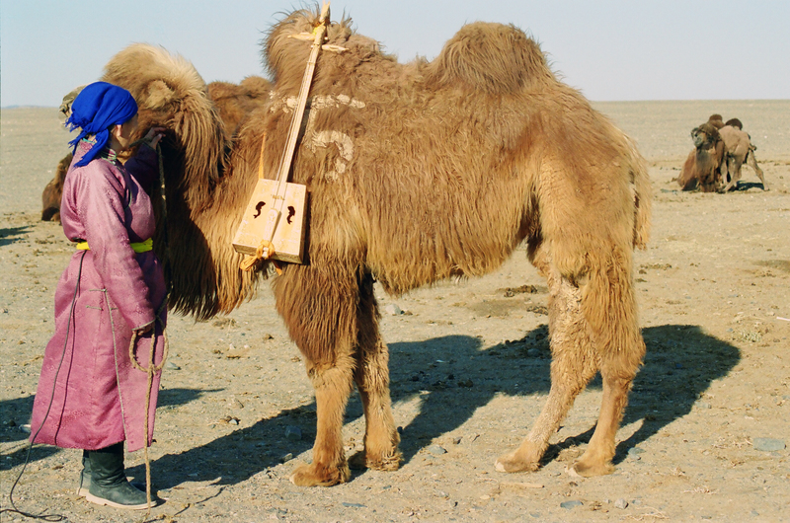

### identifier

9471cebc-7d3e-4bd1-b17c-3517233c3c17

### creator

Boldbaatar, Yu.

### type

Image

### coverage

Mongolia

Ömnögovi aimag

Khankhongor sum

### description

The coaxing ritual for baby camels-2

### publisher

### source

https://ich.unesco.org/img/photo/src/09403.jpg

### rights

### subject

### date

2011

### language

### original filename

09403.jpg

### extent

4.8 MiB

3130x2075 px

### format

image/jpeg

### modified

2016-02-24 14:45:36