Photograph of Handgate, Xinjiang by Tsui Yen Hu, 1993, No. 36

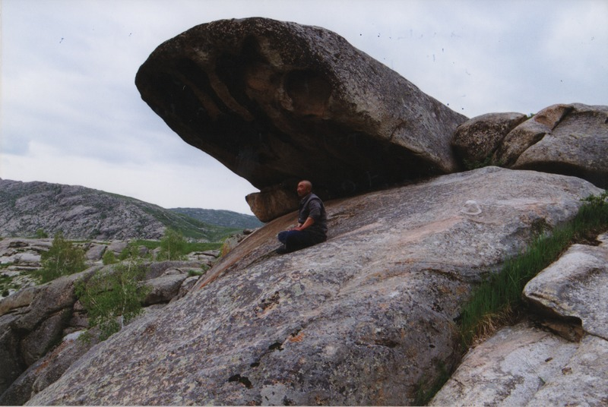

### identifier

99ed70ea-a135-4c40-a124-a977313851d5

### creator

Tsui Yen Hu

### type

Image

### coverage

Altai district

Handgate

PRC

Xinjiang

### description

A young herder sitting and meditating at Five-Finger Spring. He comes here once a week, and he said, "My soul is quiet here." Dr. Tsui observed him meditating for over half an hour.

### publisher

### source

Scanned from colour print held in the archives of the University of Cambridge MacArthur Project "Environmental and Cultural Conservation in Inner Asia", Mongolia and Inner Asia Studies Unit.

### rights

### subject

natural sacred sites

### date

1993-05-27

### language

### format

image/png

### contributor

### original filename

TsuiYenHu-Handgate-1993-36.png

### relation

### extent

1777x1191 px

3.5 MiB