4023

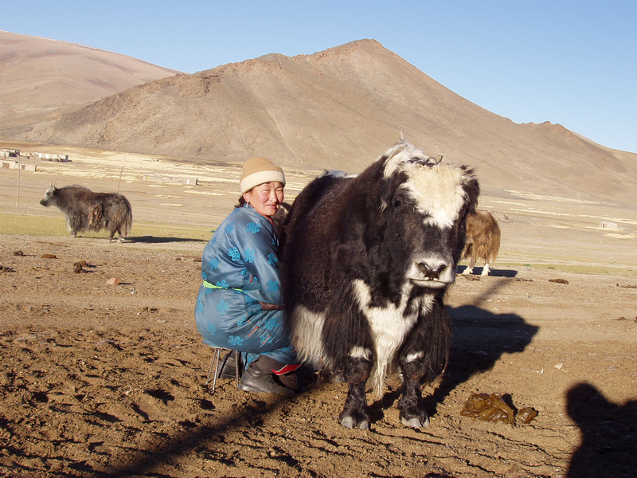

### identifier

9ac0d331-7268-43be-bd08-900a030479d9

### creator

Boldbaatar, Yu.

### type

Image

### coverage

Mongolia

### description

A woman milking a cow

### publisher

### source

https://ich.unesco.org/img/photo/src/4023.jpg

### rights

### subject

### date

2010

### language

### original filename

04023.jpg

### extent

1.5 MiB

2048x1536 px

### format

image/jpeg

### modified

2012-12-05 02:28:25