4018

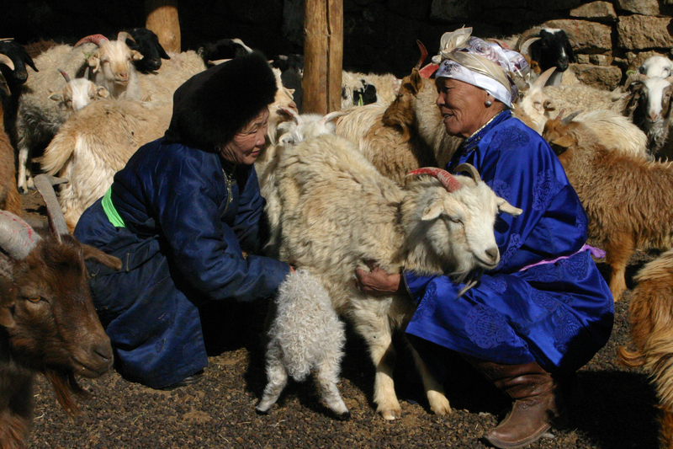

### identifier

9ac9f211-d58d-4579-94ff-93870d61be67

### creator

Boldbaatar, Yu.

### type

Image

### coverage

Mongolia

### description

Coaxing a baby sheep female goat

### publisher

### source

https://ich.unesco.org/img/photo/src/4018.jpg

### rights

### subject

### date

2010

### language

### original filename

04018.jpg

### extent

4.2 MiB

3072x2048 px

### format

image/jpeg

### modified

2012-12-05 02:28:26