2073088. Ritual to Purify Land for the Construction of a Stupa

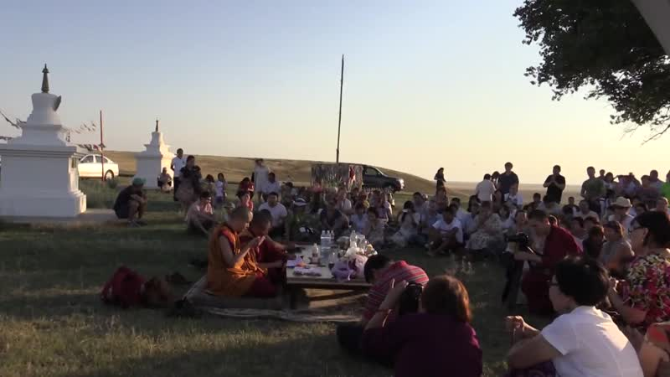

### identifier

9fc67eb2-cabb-4d61-a751-3a7495be3fb2

### creator

Kalmyk Cultural Heritage Documentation Project

### type

Moving Image

### coverage

Kalmykia

Russia

### description

### publisher

University of Cambridge

### source

<http://www.kalmykheritage.socanth.cam.ac.uk>

### rights

Copyright Kalmyk Cultural Heritage Documentation Project. Licensed under a Creative Commons BY-NC-ND Unported license.

### subject

Buddhism

Kalmyks

### date

2015-09-25 12:22:12

### language

### extent

931.1 MiB

2521.960000

### format

video/mp4

### modified

2015-09-25 04:22:12

### original filename

2073098.mp4

### remote embed url

http://sms.cam.ac.uk/media/2073088/embed

### public

FALSE