6128

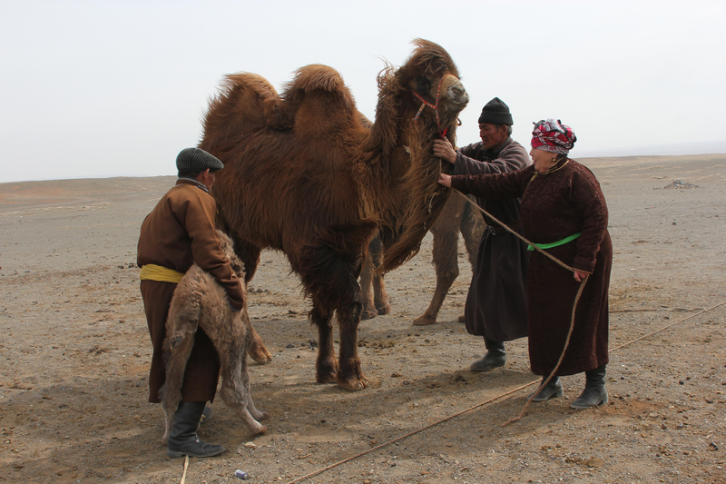

### identifier

a105cf5e-ccc2-4fc6-be94-82c50815d058

### creator

Boldbaatar, Yu.

### type

Image

### coverage

Mongolia

Ömnögovi aimag

Khankhongor sum

### description

Getting the orphan calf and the mare-camel without a calf together for coaxing (Khankhongor Sooum, Umnugobi Province)

### publisher

### source

https://ich.unesco.org/img/photo/src/6128.jpg

### rights

### subject

### date

2011

### language

### original filename

06128.jpg

### extent

8.2 MiB

4500x3000 px

### format

image/jpeg

### modified

2012-12-05 02:28:25